**Lesson12 Lifecycle Rules**

**Notes:-**

**1-by default each blob has its own access tier and its inherited from the azure storage account configuration if it set to hot, cool, archived state.**

**2-you can set policy to specific blob to change access tier from hot 🡪 cool , with added conditions as below**

**3-azure life cycle rules takes 24 hours to take action to apply on the blob change states**

**Steps:-**

**1-create azure storage account and create container and set blob**

**2-search on lifecycle management > Add Rule**

**(you can specify the target if apply to all blob types, or based on type block blob , append blob , or subtype , snapshot , version , base blob)**

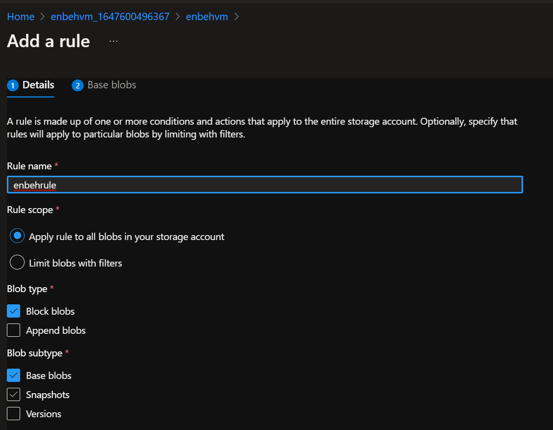

**3-you can on second step provide condition and set rule if the days =1 (if the blob remain on the storage account more than 1 days), change access tier from hot 🡪 cool**

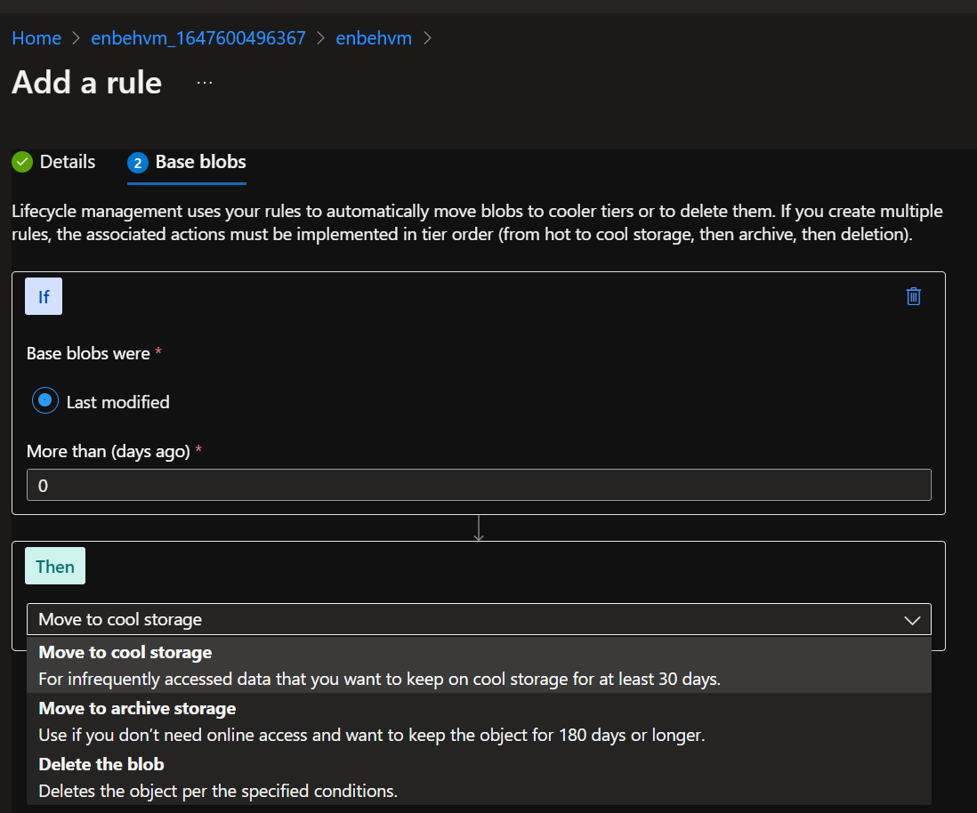

**4-you can enable / delete rule (but it takes 24 hours to take action)**

